**AIM:**  Design PDA using simulator to accept the input string anbn

**INPUT:**

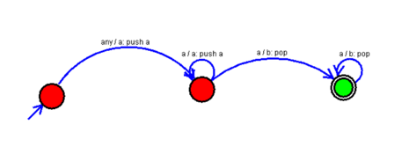

**OUTPUT:**

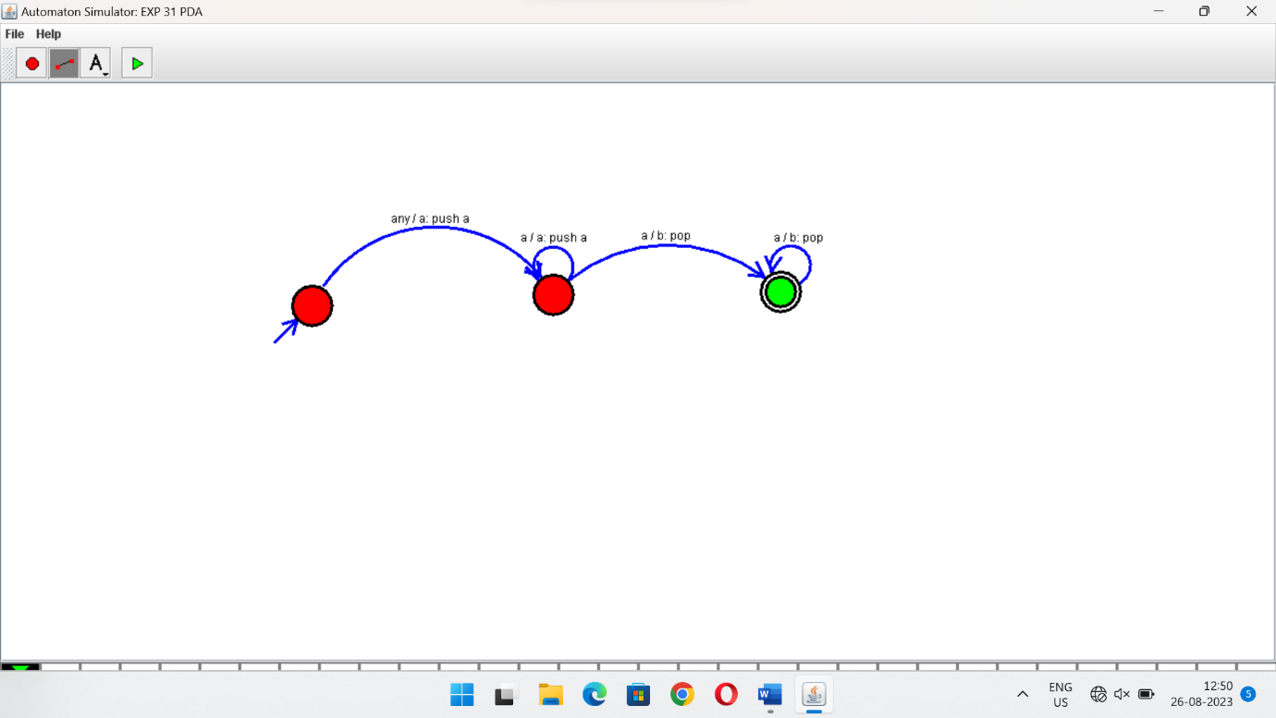

**RESULTS:**

PDA using simulator to accepting the input string anbn